**Ansible Exercise Notes**

**Day 2:**

1. Ssh
   1. Copy the Ec2 pem file in to local ubuntu desktop

\\wsl.localhost\Ubuntu\home\ganta\ansible

* 1. Ssh
     1. To check ip address : ip a
     2. Check for .ssh directory
     3. Generate ssh access key pair using :

ssh-keygen -t ed25519 -C "ganta defaullt"

* 1. Ssh connection
     1. Check ssh keys : ls -la .ssh
     2. Public key creation: cat .ssh/id_ed25519.pub
     3. Private key creation: cat .ssh/id_ed25519
  2. ssh-copy-id -f "-o IdentityFile mns.pem" [ubuntu@18.171.57.203](mailto:ubuntu@18.171.57.203)
  3. <https://www.ssh.com/academy/ssh/keygen>
     1. ssh-keygen -t ecdsa -b 521
     2. ssh-keygen -f ~/tatu-key-ecdsa -t ecdsa -b 521
  4. ssh-copy-id -i ~/tatu-key-ecdsa ubuntu@52.56.63.239

1. Building an Inventory

<https://docs.ansible.com/ansible/latest/getting_started/get_started_inventory.html>

* You must also ensure that your public SSH key is added to the authorized_keys file on each host.
* Create inventory.ini file in ansible directory
  + [web-servers]
  + ubuntu@52.56.63.239
  + [ubuntu@18.171.57.202](mailto:ubuntu@18.171.57.202)

1. Ansible adhoc commands
   1. Ping Inventory

ansible web-servers -m ping -i inventory.ini

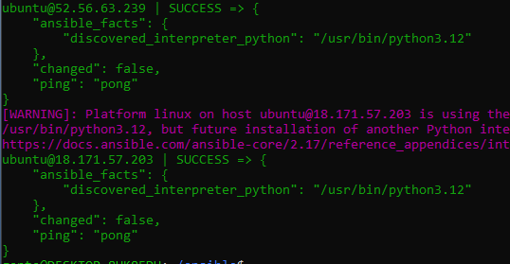

1. Ansible Playbook
   1. Create file nano pb.yml

---

- hosts: webservers

become: yes

tasks:

- name: uninstall test package and sync apt index

apt:

name: testpackage

state: absent

update_cache: yes

* 1. Install apache

---

- hosts: all

become: true

tasks:

- name: Install apache httpd

ansible.builtin.apt:

name: apache2

state: present

update_cache: yes

- name: Copy file with owner and permissions

ansible.builtin.copy:

src: index.html

dest: /var/www/html

owner: root

group: root

mode: '0644'

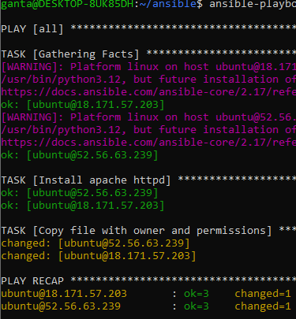

* 1. Ansible roles

<https://blog.dineshcloud.in/ansible-roles>

